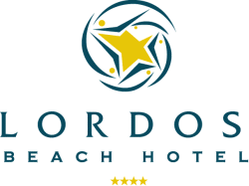 | RESERVATION FORM  Tel.: 357 24647444 Fax: 357 24 647450  E-mail: reservations@lordosbeach.com.cy  www.lordosbeach.com.cy
LARNACA - CYPRUS
INES 2017 October 20 – 23, 2017
Larnaca - Cyprus

Deadline for reservations: 31st August, 2017

Delegate’s name: …………………………………………………………….

Accompanying person’s name: ……………………………………………….
(if applicable)

Tel.: ………………………………..

Fax………………………………….

E-mail: ……………………………..

Date of Arrival:.........................................

Date of Departure:....................................

Type of room required: | Room rates are on BB  Single SSV Double SSV  85,00 euro 110,00 euro  (incl.wifi in rooms)  No of Adults :
Credit card number……………………….. Expiry date…………………………..

Date: ……………………………………… Signature…………………………….

